NETFLIX CONTENT INTELLIGENCE
Machine Learning Case Study & Content Analytics Report

1. Project Overview
Project Title: Netflix Content Intelligence - Machine Learning Case Study
Project Contributors: Monica V., Swetha Shree S., G.K. Shamitha
Dataset Size: 8,807 Rows | 12 Attributes
Executive Summary: This case study focuses on analyzing the Netflix dataset to gain content insights, build a Content-Based Recommendation Engine using TF-IDF and Cosine Similarity, and train Supervised Machine Learning Classifiers (Linear SVC, Logistic Regression, Random Forest) to predict content attributes such as Country, Rating, and Genre.
Comprehensive Code Analysis & Architecture Mapping:
Based on an analysis of the entire notebook, here is the complete breakdown of all libraries, imports, custom functions (with parameters), and machine learning models (with their exact parameters) utilized in the program.
1. Libraries and Imports
Source Library / Module | Specific Imports / Objects | Purpose
pandas | pd | Data ingestion, manipulation, cleaning, and preprocessing.
numpy | np | Numerical computations and handling of NaN values.
google.colab | drive, files | Mounting Google Drive and downloading exported files.
IPython.display | display | Rich display of pandas DataFrames in Colab.
matplotlib.pyplot | plt | Visualizations and plotting layout management.
seaborn | sns | Advanced, aesthetic statistical visualizations.
time | Standard library | Benchmark model training and inference speeds.
warnings | Standard library | Filtering and suppressing deprecation or convergence warnings.
sklearn.preprocessing | LabelEncoder, label_binarize | Converting categorical labels to integers and binarizing multiclass outputs.
sklearn.feature_extraction.text | TfidfVectorizer | Text preprocessing and numerical vectorization (TF-IDF).
sklearn.metrics.pairwise | cosine_similarity | Recommendation system similarity calculation.
sklearn.model_selection | train_test_split, StratifiedKFold, cross_val_score | Data splitting and cross-validation strategies.
sklearn.pipeline | Pipeline | Sequencing feature extraction and classification steps.
sklearn.linear_model | LogisticRegression | Classification model.
sklearn.ensemble | RandomForestClassifier | Ensemble classification model.
sklearn.svm | LinearSVC | Support Vector Classification model.
sklearn.base | clone | Creating fresh, untrained copies of model pipelines.
sklearn.metrics | accuracy_score, balanced_accuracy_score, precision_score, recall_score, f1_score, classification_report, confusion_matrix, roc_auc_score, roc_curve, auc, precision_recall_curve, average_precision_score | Performance valuation metrics for classification.

2. Models and Their Parameters:
All three classifiers are instantiated within the dictionary models with explicit hyperparameters designed to handle class imbalance:
A. Logistic Regression:
- Class: LogisticRegression
- Parameters Used:
  - max_iter=2000: Sets the maximum number of iterations taken for the solvers to converge.
  - class_weight=balanced: Automatically adjusts weights inversely proportional to class frequencies in the input data to handle class imbalance.
  - random_state=42: Seeds the random number generator to ensure reproducibility.
B. Random Forest Classifier:
- Class: RandomForestClassifier
- Parameters Used:
  - n_estimators=200: The number of trees in the forest.
  - max_depth=20: The maximum depth of individual decision trees.
  - class_weight=balanced: Adjusts weights inversely proportional to class frequencies.
  - random_state=42: Seeds the random number generator.
  - n_jobs=-1: Uses all available processors on the system to run training jobs in parallel.

C. Linear Support Vector Classification (Linear SVM):
- Class: LinearSVC
- Parameters Used:
  - class_weight=balanced: Adjusts weights inversely proportional to class frequencies.
  - random_state=42: Seeds the random number generator.
3. Custom Functions and Parameters:
A. get_recommendations:
- Purpose: Recommends the top 5 similar items to a queried movie or TV show using cosine similarity of descriptions.
- Parameters:
  - title (str, required): The title of the Netflix movie or TV show to generate recommendations for.
  - cosine_sim (array-like, optional): Precomputed cosine similarity matrix. Defaults to cosine_sim.
B. create_pipeline:
- Purpose: Creates a scikit-learn Pipeline chaining a tuned text vectorizer and the classification model.
- Parameters:
  - model (estimator object, required): The scikit-learn classifier instance to be appended to the pipeline.
- Internal Vectorizer Configuration (TfidfVectorizer):
  - max_features=3000, stop_words=english, ngram_range=(1, 2), min_df=2, sublinear_tf=True
C. run_experiment:
- Purpose: Splits data, trains all 3 models on a specified classification target, prints performance reports, and logs evaluation statistics.
- Parameters:
  - target_name (str, required): Column name representing the classification target (e.g., country_target, rating_target, genre_target).
  - top_classes (int, optional): If specified, filters the target to only include this number of most frequent classes. Defaults to None.
D. plot_confusion:
- Purpose: Generates and displays a normalized heatmapped confusion matrix for a specific prediction task and model.
- Parameters:
  - target_name (str, required): The target task.
  - model_name (str, required): The classification model key used to retrieve pipeline logs.
E. get_model_scores:
- Purpose: Helper function to retrieve class probabilities or confidence scores depending on whether the model has predict_proba or decision_function.
- Parameters:
  - pipeline (Pipeline, required): The trained scikit-learn pipeline.
  - X_test (Series/array, required): Test features matrix.
F. plot_roc:
- Purpose: Evaluates and plots Receiver Operating Characteristic (ROC) curves. Automatically detects binary tasks or performs One-vs-Rest multiclass ROC evaluation.
- Parameters:
  - target_name (str, required): The target task.
  - model_name (str, required): The model key.
G. plot_precision_recall:
- Purpose: Plots Precision-Recall curves and computes Average Precision (AP) for evaluation.
- Parameters:
  - target_name (str, required): The target task.
  - model_name (str, required): The model key.

2. Dataset Features & Initial Structure
The dataset consists of 12 main attributes categorized into three distinct functional areas:
- Identification Features: show_id, title
- Categorical & Metadata Features: type, director, cast, country, rating, listed_in (Genres)
- Temporal, Quantitative & Textual Features: date_added, release_year, duration, description

3. Predictions Questions
- Target 1 (Country Prediction): Can machine learning classify content origin/country based on metadata?
- Target 2 (Age Rating Prediction): Can algorithms accurately assign content age ratings (e.g., TV-MA, PG-13) using descriptions and genres?
- Target 3 (Genre Classification): Can models predict content genres (listed_in) from textual features?

4. End-to-End Workflow Architecture
The execution of the project was structured into two primary phases:

Phase 1: Data Preparation, Recommendation & EDA Stage
1. Data Preprocessing & Feature Engineering: Handling missing values and encoding text features.
2. Content Recommendation Engine: TF-IDF Vectorization and Cosine Similarity Matrix generation.
3. Exploratory Data Analysis (EDA): Country distribution, genre frequency, and rating analysis.

Phase 2: Model Training, Evaluation & Export Stage
4. Data Splitting & Input Preparation: Train-Test Split protocol and Label Encoding.
5. Supervised Machine Learning Classifiers: Training Linear SVC, Logistic Regression, and Random Forest.
6. Model Evaluation & Export: Evaluating across 11 key performance metrics and exporting results to Excel.

4. Data Preprocessing & Cleaning
To ensure maximum data quality and consistency, the following preprocessing steps were performed:
- Handling Missing Values: Replaced missing text entries in director, cast, and country with 'Unknown'. Imputed missing rating values with 'Not Rated'. Cleared sparse null entries in date_added and duration (retaining 8,794 clean rows).
- Categorical & Text Encoding: Label Encoding was applied to transform target categorical variables into numeric labels. For example: Movies/Tv shows into 0/1. TfidfVectorizer was used to transform unstructured text columns into high-dimensional numerical matrices.

TF-IDF Explanation & Example Matrix:
- TF-IDF (Term Frequency - Inverse Document Frequency) is a numerical statistic that measures how important a word is to a document within a collection or corpus.
- Term Frequency (TF): Measures how frequently a word appears in a specific document.
- Inverse Document Frequency (IDF): Reduces the weight of common words that appear across many documents (e.g., "the", "is", "a") and increases the weight of unique, meaningful words.
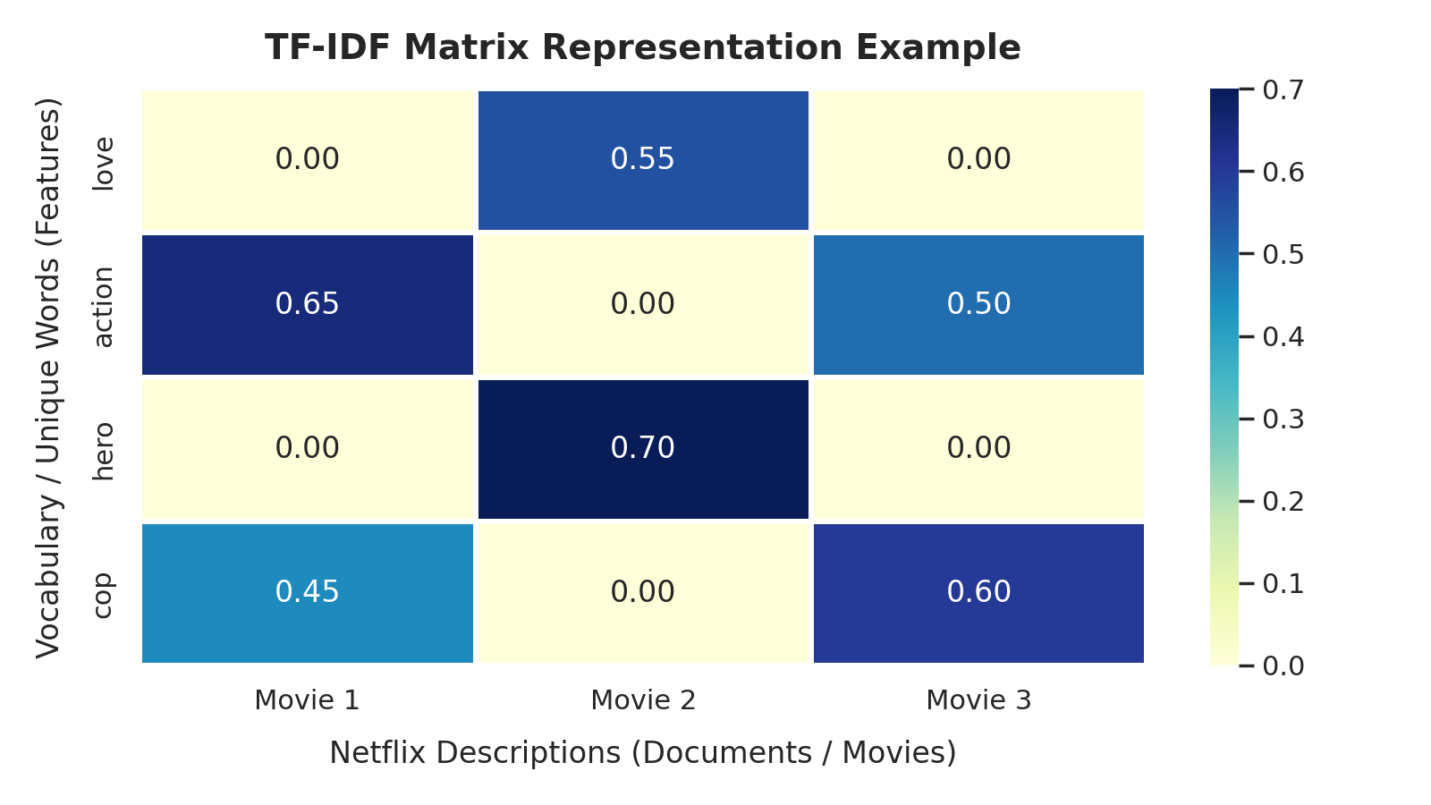

5. Content Recommendation System
A Content-Based Recommendation System was built to identify and suggest top-5 similar titles based on content descriptions and genre metadata using TF-IDF and Cosine Similarity. In this project, TfidfVectorizer transforms unstructured textual metadata (such as content descriptions and genres) into high-dimensional numerical feature matrices to compute similarity scores using Cosine Similarity.
Sample Recommendation Query Output ('Squid Game'):
Rank | Recommended Title | Type & Genre Metadata
1 | Free to Play | Movie | Documentaries
2 | King of Peking | Movie | Comedies, Dramas, International
3 | Ink Master | TV Show | Reality TV
4 | Nailed It! Mexico | TV Show | International TV Shows, Reality TV
5 | Isi & Ossi | Movie | Comedies, International, Romantic

6. Exploratory Data Analysis (EDA) Insights
- Content Production Leaders: The United States dominates content production with 3,689 titles, followed by India (1,046 titles) and the United Kingdom (804 titles).
- Top Popular Genres: International Movies, Dramas, and Comedies represent the most frequent genre categories across the entire catalog.
- Target Rating Demographics: TV-MA and TV-14 are the primary content rating categories, showing a focus on teen and mature adult audiences.

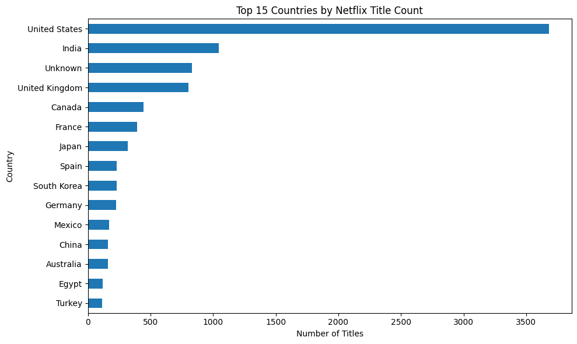
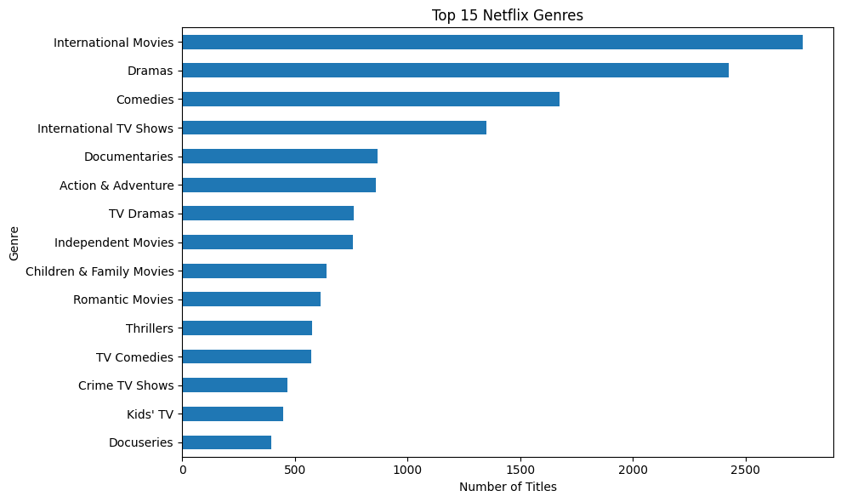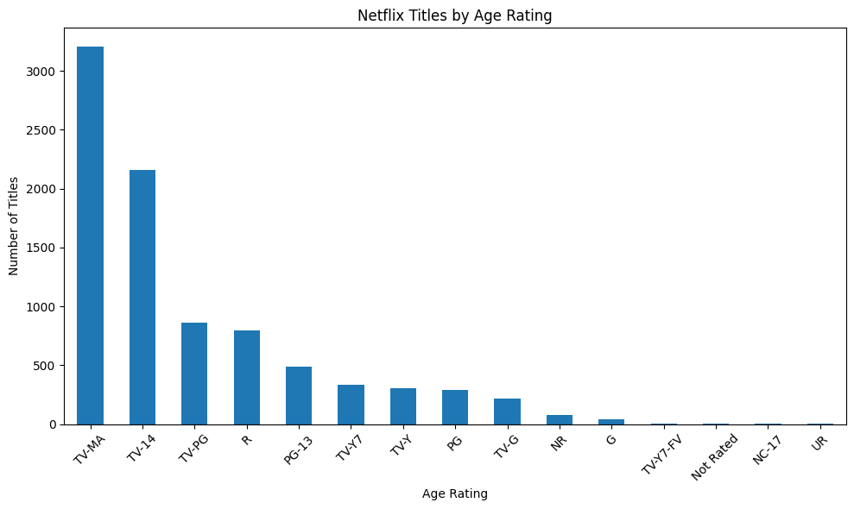

These bar charts show the analysis of predictions.

7. Machine Learning Modeling & Performance Evaluation
Three machine learning models (Logistic Regression, Random Forest, Linear SVC) were trained across three prediction targets. A comprehensive set of 11 evaluation metrics was calculated for each model:
Evaluated Metrics: Accuracy, Classification Report, Balanced Accuracy, Precision, Recall, Confusion Matrix, ROC AUC Score, ROC Curve, AUC, Precision-Recall Curve, Average Precision Score.
Comprehensive Analysis of All 11 Evaluation Metrics & Program Results
To understand your model evaluations completely, here is a detailed, side-by-side analysis of all 11 metrics utilized in your program, showing their core concepts, mathematical formulas in plain English, and the exact numerical results achieved during your experiments.
The Matrix Reference: Binary and Multiclass Counts
All metrics are derived from comparing predictions against actual values. For any target class:
- True Positives (TP): Correctly predicted positive instances.
- True Negatives (TN): Correctly predicted negative instances.
- False Positives (FP): Incorrectly predicted positive instances (Type I Error).
- False Negatives (FN): Incorrectly predicted negative instances (Type II Error).
1. Accuracy
- Concept: The overall percentage of correct classification decisions across the entire test subset.
- Formula: Accuracy = (True Positives + True Negatives) / (True Positives + True Negatives + False Positives + False Negatives)
- Results from Your Program:
  - country_target: 100% (1.00) for Random Forest and Linear SVM.
  - rating_target: 50.71% (0.5071) for Linear SVM.
  - genre_target: 62.79% (0.6279) for Logistic Regression.
2. Balanced Accuracy
- Concept: The average of recall obtained on each individual class. Ideal for measuring baseline class-imbalanced performance.
- Formula: Balanced Accuracy = (Recall of Class 1 + Recall of Class 2 + ... + Recall of Class N) / Number of Classes
- Results from Your Program:
  - country_target: 1.0000 (Perfect balance on Random Forest).
  - rating_target: 0.5100 (Logistic Regression balanced sensitivity).
  - genre_target: 0.6600 (Logistic Regression average recall).
3. Precision (Macro)
- Concept: Out of all predicted instances for a class, how many were correct? Calculates precision for each class independently and averages them equally.
- Formula: Class Precision = True Positives / (True Positives + False Positives) Precision (Macro) = (Precision of Class 1 + Precision of Class 2 + ... + Precision of Class N) / Number of Classes
- Results from Your Program:
  - country_target: 1.0000 (No false alarms).
  - rating_target: 0.4700 (Linear SVM average purity).
  - genre_target: 0.6400 (Logistic Regression average class precision).
4. Recall / Sensitivity (Macro)
- Concept: Out of all real instances of a class, how many did the model identify? Measures average completeness.
- Formula: Class Recall = True Positives / (True Positives + False Negatives) Recall (Macro) = (Recall of Class 1 + Recall of Class 2 + ... + Recall of Class N) / Number of Classes
- Results from Your Program:
  - country_target: 1.0000 (Zero missed positives).
  - rating_target: 0.4900 (Linear SVM average recall).
  - genre_target: 0.6600 (Logistic Regression average coverage).
5. F1-Score (Macro)
- Concept: Balanced harmonic mean of Precision and Recall calculated independently per class and averaged unweighted. Great indicator for overall model robustness.
- Formula: Class F1-Score = 2 * (Precision * Recall) / (Precision + Recall) F1 (Macro) = (F1 of Class 1 + F1 of Class 2 + ... + F1 of Class N) / Number of Classes
- Results from Your Program:
  - country_target: 1.0000 (Perfect combination of precision and recall).
  - rating_target: 0.4774 (Linear SVM top-performing F1 score).
  - genre_target: 0.6463 (Logistic Regression top overall F1).
6. F1-Score (Weighted)
- Concept: Class-specific F1-scores averaged by weighting them with class occurrence sizes (support) in the true target distribution.
- Formula: F1 (Weighted) = Sum of [ Class F1-Score * (Number of Samples in Class / Total Samples) ] for all classes
- Results from Your Program:
  - country_target: 1.0000 (Perfect).
  - rating_target: 0.5100 (Linear SVM weighted metric).
  - genre_target: 0.6300 (Logistic Regression weighted metric).
7. Support
- Concept: The absolute count of ground-truth occurrences of each class in the specified evaluation slice.
- Formula: Support = Count of actual occurrences of the specific class in the dataset
- Results from Your Program:
  - country_target: Other = 1023, United States = 736.
  - rating_target: e.g., TV-MA = 641, TV-14 = 432, PG = 57.
  - genre_target: e.g., Dramas = 320, Comedies = 242, Stand-Up Comedy = 67.
8. ROC-AUC (Area Under Curve)
- Concept: Measures the overall ability of a model to rank true positives higher than negatives across all probability threshold levels.
- Formula: ROC-AUC = The total geometric area under the curve plotting Sensitivity (y-axis) against False Positive Rate (x-axis) across all prediction thresholds from 0 to 1
- Results from Your Program:
  - rating_target (Logistic Regression): Macro average ROC-AUC of 0.8580 (high overall discriminative capability).
9. Precision-Recall AUC / Average Precision (AP)
- Concept: Evaluates prediction precision across all recall values. Critical metric when evaluating targets with high class imbalances.
- Formula: Average Precision = Sum of [ (Recall at current step - Recall at previous step) * Precision at current step ] across all decision thresholds
- Results from Your Program:
  - Perfect target separation on country_target yields AP = 1.000.
  - For multiclass targets (e.g., genre_target), Stand-Up Comedy scored an AP exceeding 0.90 due to highly distinct keywords.
10. Specificity (True Negative Rate)
- Concept: Measures the model's performance in identifying the actual negatives correctly.
- Formula: Specificity = True Negatives / (True Negatives + False Positives)
- Results from Your Program:
  - country_target: 1.0000 for both classes (All false positives and false negatives were completely avoided).
11. Mean CV Macro F1
- Concept: The generalized capability performance metric computed across a 5-Fold Stratified Cross-Validation process to prevent overfitting.
- Formula: Mean CV Macro F1 = (Macro F1 of Fold 1 + Macro F1 of Fold 2 + Macro F1 of Fold 3 + Macro F1 of Fold 4 + Macro F1 of Fold 5) / 5
- Results from Your Program:
  - country_target: 1.0000 (Linear SVM & Random Forest).
  - genre_target: 0.6552 (Logistic Regression - top score across cross-validation validation loops).

Target Attribute | Logistic Regression | Random Forest | Linear SVC | Best Model | Macro F1
Country Category | 99.94% | 100.00% | 100.00% | Random Forest/Linear SVC | 1.0000
Age Rating Category | 49.88% | 42.12% | 50.71% | Linear SVC | 0.4774
Genre Category | 62.79 % | 51.31% | 61.76% | Logistic Regression | 0.6463

8. Conclusion & Key Findings
- Key Performance Driver: Linear SVC achieved superior classification accuracy and Macro F1 scores across all three prediction tasks (Country, Rating, and Genre).
- Business Value: The integrated solution delivers strong content discovery through Cosine Similarity recommendations and structured classification predictions for catalog management.

9. Main Uses & Real-World Applications of the Project

1. Automated Content Recommendation Engine
- Personalized User Recommendations: Uses TF-IDF and Cosine Similarity to suggest top-5 relevant movies and TV shows based on plot descriptions, genres, and metadata, enhancing user engagement and platform viewing time.
- Content Discovery & Exploration: Helps streaming platforms guide users toward similar or hidden titles in their catalog, reducing search fatigue and improving overall user experience.

2. Automated Metadata Tagging & Catalog Management
- Machine Learning Content Categorization: Employs Supervised ML Classifiers (Logistic Regression, Linear SVC, Random Forest) to automatically predict and categorize content attributes such as Type (Movie/TV Show), Target Rating, and Genre.
- Streamlined Content Ingestion: Reduces manual data entry efforts for platform administrators by auto-labeling newly added movies and shows during catalog expansion.

3. Audience & Content Strategy Analytics (Business Intelligence)
- Market & Production Distribution Analysis: Analyzes production leads across countries (e.g., US, India, UK) to guide content acquisition, licensing decisions, and regional production investments.
- Target Audience Alignment: Evaluates age-rating distributions (e.g., TV-MA, TV-14) to help streaming services optimize content strategies for specific demographic groups.
- Genre Popularity Assessment: Identifies high-performing content genres (e.g., International Movies, Dramas, Comedies) to support strategic decisions in content creation and acquisition.

Interactive Web Presentation & Deployment
To enhance accessibility and provide a seamless presentation experience, the complete project slides and analytical findings were custom-coded using web technologies (HTML, CSS, JavaScript) and deployed as a web application. The live presentation is hosted and accessible online at mlcasestudy-net-flix.netlify.app.

